**How to lock out a user after some number of wrong password attempts:**

You can refer to my other documentation on how to use the Data Steward if you need to create a new user.

Log into your local i2b2 admin tool and navigate to the user that you wish to modify. Click on that user’s username. For the purposes of this demonstration, I am using our ‘test user’. Once you have selected the user, click on ‘Params’ and then click on the ‘Add New Parameter’ button in the center console.

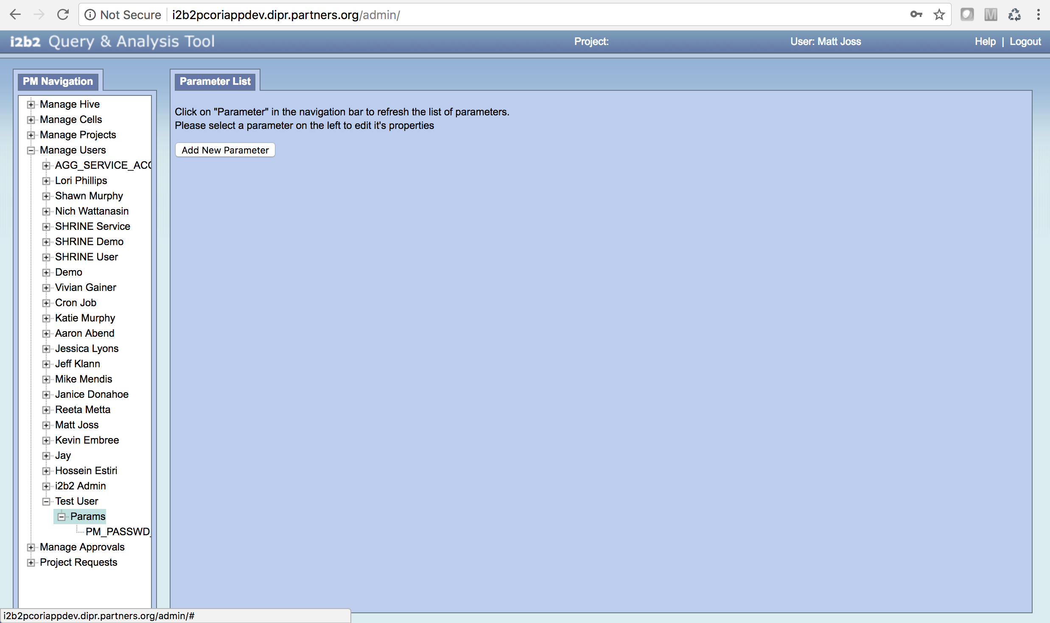

Once you click on the add new parameter button, fill in the text boxes as seen in the image below. The ‘Parameter Name’ should be entered as ‘PM_PASSWD_RETRY’ and the ‘Parameter Value’ should be entered as ‘7’ or whichever number your site chooses is appropriate.

Make sure to click the ‘Save’ button at the bottom to save this new parameter

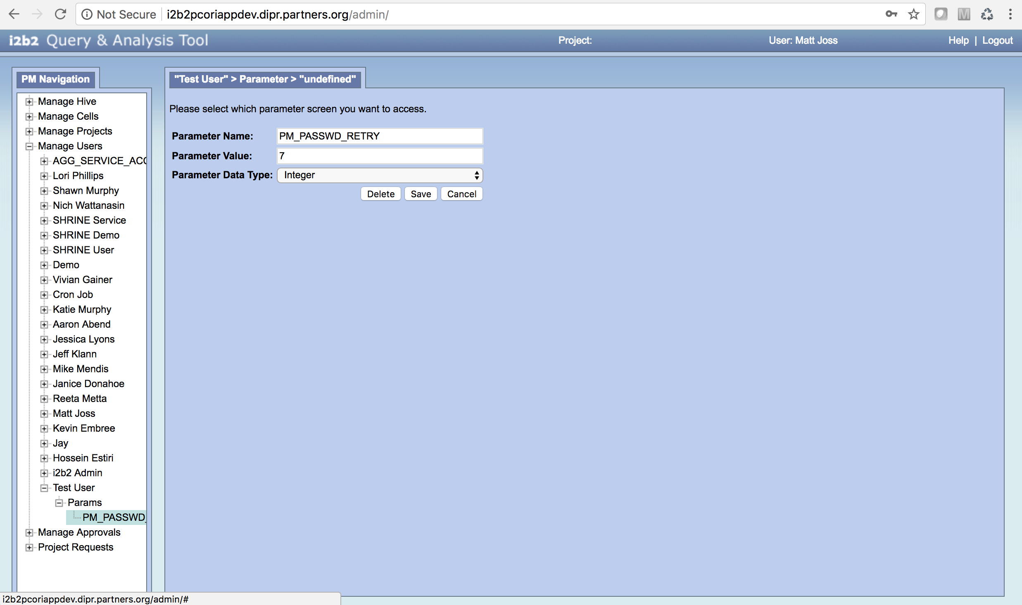

Once this parameter has been saved, there is nothing left to do! This user will now be temporarily locked out of the i2b2 login page if they have 7 wrong password entries in a short period of time. The lockout period is not long, only about 15 minutes.